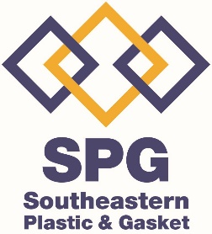 CAPABILITY STATEMENT
NAICS Codes

339991 - Gasket, Packing, and

Sealing Device Manufacturing

332710 - Machine Shops

333514 - Special Die and Tool, Die Set,

Jig, and Fixture Manufacturing

Southeastern Plastic & Gasket offers our customers quality gaskets, precision machined parts and raw materials. We emphasize on customer service and competitive pricing while making on-time deliveries a priority. We have developed a Team that has 40+ years of sales experience in the plastic industry. Our sister company, Southeastern Tool provides over 59 years of proven performance and reliability. Our 25,000 sq ft facility is equipped with both manual and CNC mills and lathes, a grinding department and a complete fabrication department. SPG Gaskets are manufactured by waterjet as well as die cut.

Business Structure:
Southeastern Plastic & Gasket is a Woman Owned Small Business and Registered LLC

CORE CAPBILITIES
Water Jet Cutting <> CNC Milling & Turning <> Sawing Manual Machining <> Mechanical & Hydraulic Presses Optical Comparator Inspections

CUSTOMER BASE
Shaw Industries- Aiken, SC
GULBRANDSEN – Orangeburg, SC
Palmetto Tool – Barnwell, SC
Contact Information

Kim Cheeks, CFO / Controller
Phone: 803 514-4122
Email – Kim.SEPG@gmail.com

Lee Cheeks, Operations Manager
Phone: 803 645-4345
Email: Sales.SEPG@gmail.com

3231 Wagener Road * Aiken, SC 29801

www.PlasticAndGasket.com

HUBBELL Power Systems – Aiken, SC
Southeastern Tool – Aiken, SC
VB Hook – West Columbia, SC
Aiken Mechanical – Aiken, SC
Dixie Belle Farms – Trenton, SC

DIFFERENTIATORS

* Local Presence
* Quick Response
* Experienced Sales Team
* Short Lead Times
* Inhouse Production
* Wide Range of Manufacturing Capabilities

